

Semester One Examination, 2016

Question/Answer Booklet

MATHEMATICS

SOLUTIONS
APPLICATIONS
UNIT 3

Section One:

Calculator-free

Student Number: In figures

In words

Your name

Time allowed for this section
Reading time before commencing work: five minutes
Working time for section: fifty minutes

Materials required/recommended for this section
To be provided by the supervisor
This Question/Answer Booklet
Formula Sheet

To be provided by the candidate
Standard items: pens (blue/black preferred), pencils (including coloured), sharpener, correction fluid/tape, eraser, ruler, highlighters

Special items: nil

Important note to candidates
No other items may be taken into the examination room. It is your responsibility to ensure that you do not have any unauthorised notes or other items of a non-personal nature in the examination room. If you have any unauthorised material with you, hand it to the supervisor before reading any further.

Structure of this paper

Section | Number of questions available | Number of questions to be answered | Working  time (minutes) | Marks available | Percentage of exam
Section One:  Calculator-free | 7 | 7 | 50 | 50 | 35
Section Two:  Calculator-assumed | 12 | 12 | 100 | 100 | 65
 |  |  | Total | 150 | 100

Instructions to candidates

- The rules for the conduct of examinations are detailed in the school handbook. Sitting this examination implies that you agree to abide by these rules.

- Write your answers in this Question/Answer Booklet.

- You must be careful to confine your response to the specific question asked and to follow any instructions that are specified to a particular question.

- Spare pages are included at the end of this booklet. They can be used for planning your responses and/or as additional space if required to continue an answer.
- Planning: If you use the spare pages for planning, indicate this clearly at the top of the page.
- Continuing an answer: If you need to use the space to continue an answer, indicate in the original answer space where the answer is continued, i.e. give the page number. Fill in the number of the question that you are continuing to answer at the top of the page.

- Show all your working clearly. Your working should be in sufficient detail to allow your answers to be checked readily and for marks to be awarded for reasoning. Incorrect answers given without supporting reasoning cannot be allocated any marks. For any question or part question worth more than two marks, valid working or justification is required to receive full marks. If you repeat any question, ensure that you cancel the answer you do not wish to have marked.

- It is recommended that you do not use pencil, except in diagrams.

- The Formula Sheet is not to be handed in with your Question/Answer Booklet.

Section One: Calculator-free 35% (50 Marks)
This section has seven (7) questions. Answer all questions. Write your answers in the spaces provided.

Working time for this section is 50 minutes.

Question 1 (7 marks)
(a) Re-draw the following graph to clearly demonstrate that it is planar. (3 marks)

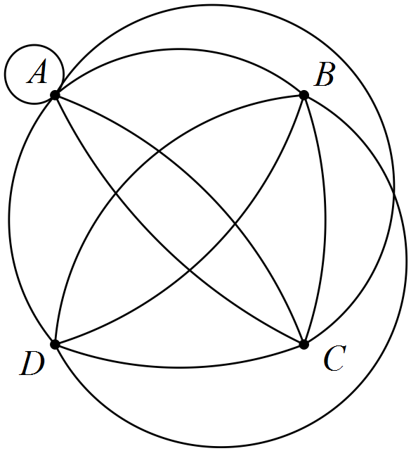
Solution
Tip: Remove loops and multiple edges, redraw without crossings, add loops, etc back
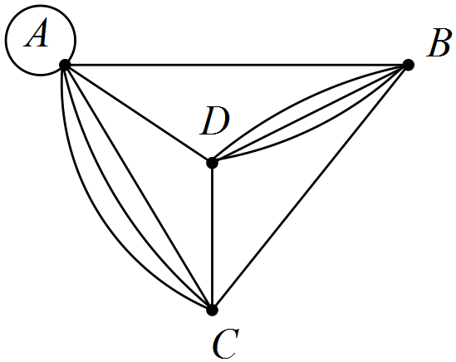
Specific behaviours
has no edges crossing
AC and BD both have three connecting edges
correct equivalent graph

(b) Draw a complete graph with five vertices. (2 marks)
Solution
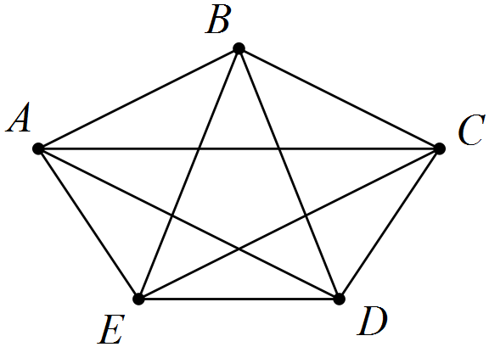
Specific behaviours
draws graph with five vertices
connects each vertex to all others

(c) Do all complete graphs obey Euler's formula? Justify your answer. (2 marks)
Solution
No - complete graphs with more than 4 vertices are not planar and Euler's rule only applies to connected planar graphs.
Specific behaviours
states no
states valid reason

Question 2 (8 marks)
The scatterplot below, with least-squares line displayed, shows the relationship between two numerical variables, x and y. The correlation coefficient between the variables is 0.92.

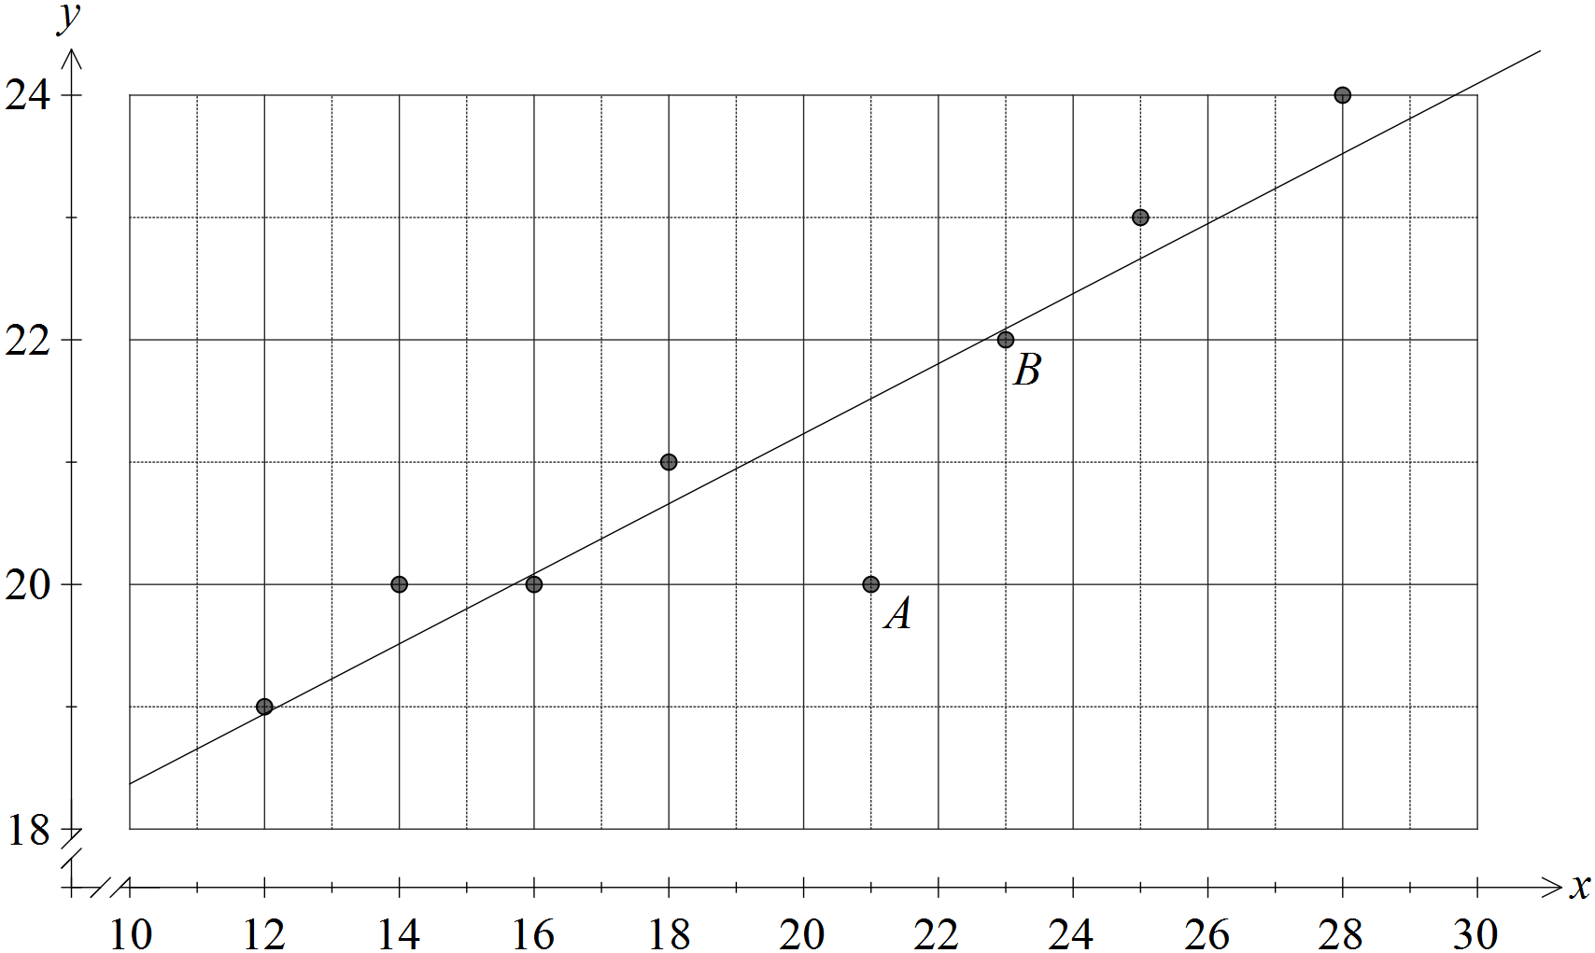

(a) Describe the association between x and y in terms of direction and strength.
(2 marks)
Solution
Strong, positive association
Specific behaviours
states positive direction
states moderate to strong strength

(b) Describe the effect on the correlation coefficient if

(i) the point labelled A was removed from the dataset. (1 mark)
Solution
Coefficient would increase, becoming closer to 1.
Specific behaviours
states increase

(ii) the point labelled B was removed from the dataset. (1 mark)
Solution
Coefficient would decrease, becoming closer to 0.
Specific behaviours
states decrease

(c) Sketch a residual plot for the eight paired values on the axes below. (3 marks)

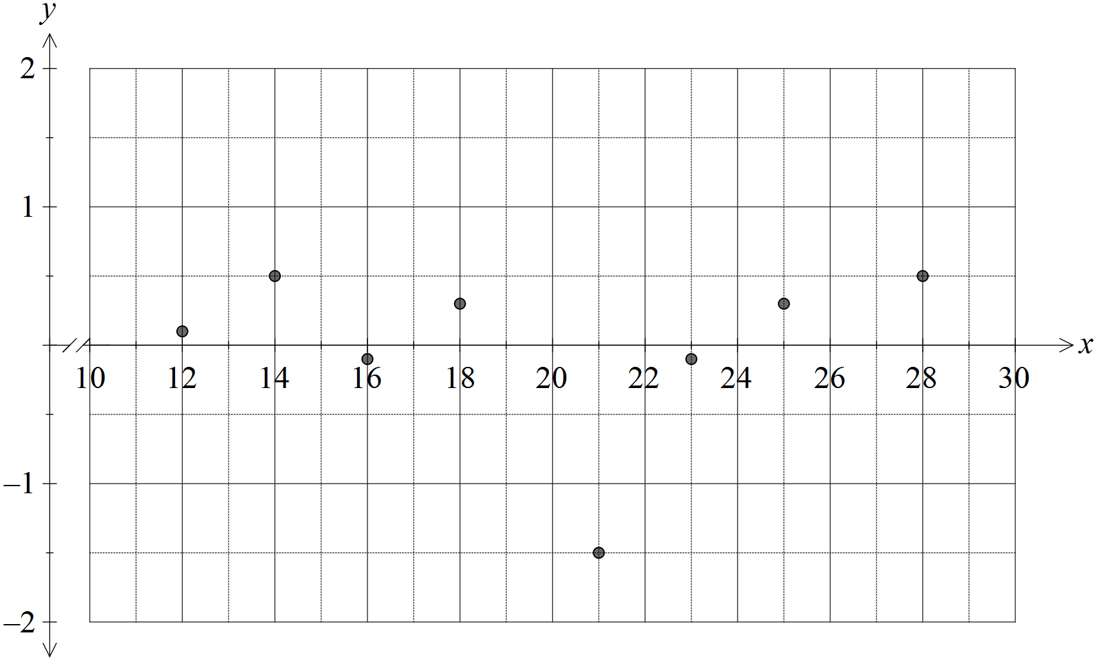
Solution
See graph - allow some latitude for estimating residuals by eye
Specific behaviours
plots at least 6 residuals above or below x-axis, as appropriate
magnitude of at least 6 residuals approximately correct
plots all residuals correctly

(d) Comment, with reasons, on the appropriateness of fitting a linear model to this dataset.
(1 mark)
Solution
Linear model is appropriate because no pattern is evident in the residuals.
Specific behaviours
states appropriate with reason

Question 3 (6 marks)
(a) Three hikers were sharing tips about walking on four famous routes. Ahn had walked the Inca Trail, Kilimanjaro and the Snowman Trek. Bi had walked the Inca Trail, Kilimanjaro and the Overland Track. Chris had walked the Overland Track and the Snowman Trek.

Display this information as a bipartite graph. (2 marks)
Solution
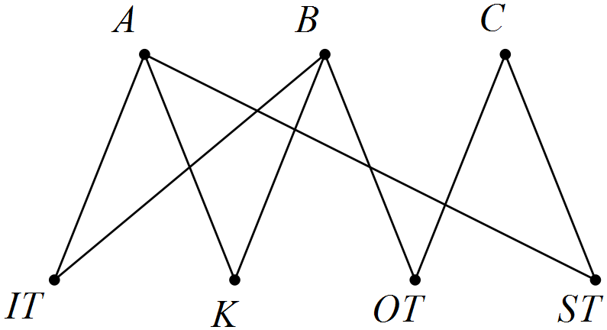
Specific behaviours
displays two sets of vertices
joins vertices correctly

(b) A bipartite graph is shown below, joining vertices in two disjoint sets. Clearly list the vertices belonging to each of the two sets. (2 marks)

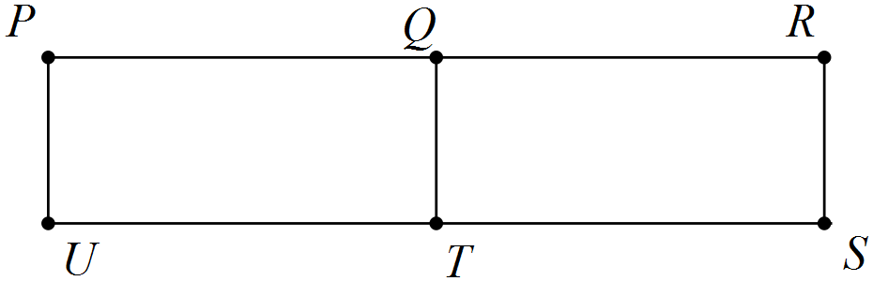
Solution
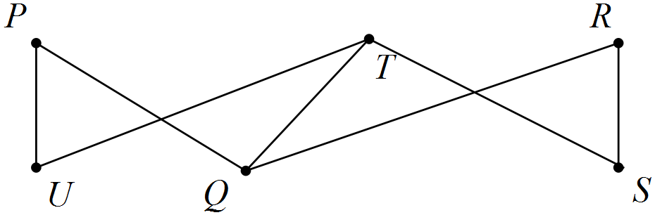
Sets are {P, T, R} and {U, Q, S}
Specific behaviours
redraws graph
lists both sets

(c) A complete bipartite graph has six vertices. Determine the smallest possible number of edges. (2 marks)
Solution
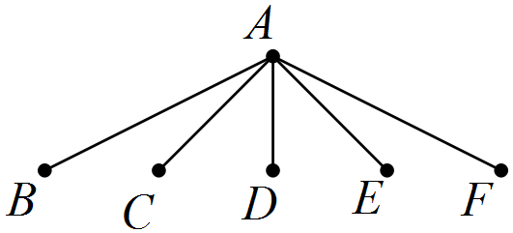
Answer: 5 edges
Specific behaviours
sketches possible graphs
states correct minimum number

Question 4 (8 marks)
The terms of a sequence are shown in the graph below.

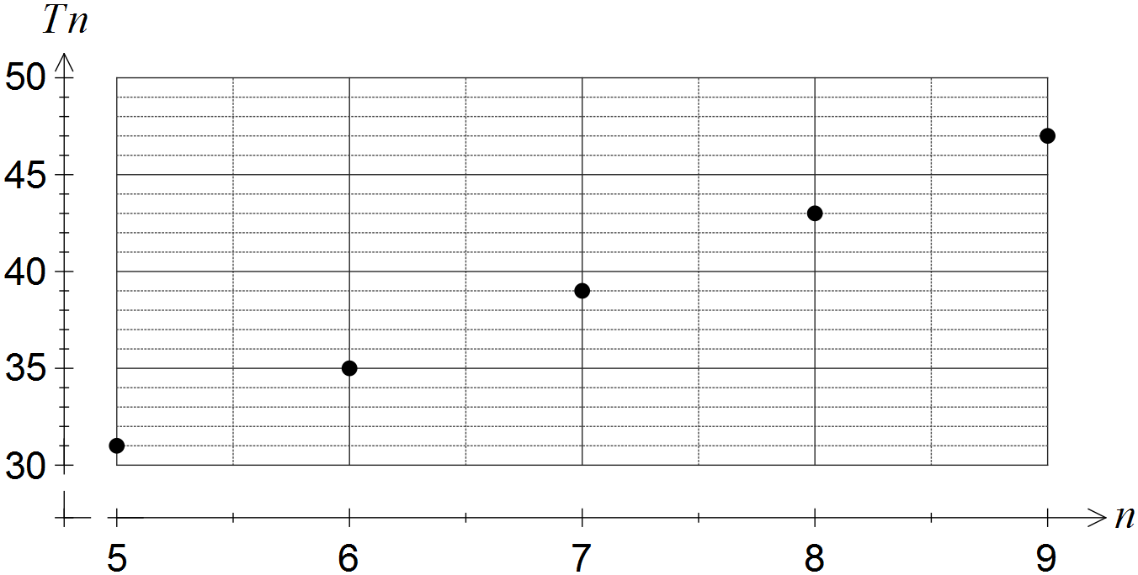

(a) Choose the best description of the sequence from geometric, arithmetic or neither, explaining your choice. (2 marks)
Solution
Arithmetic - the terms have a constant difference of 4.
Specific behaviours
chooses arithmetic
refers to constant difference between consecutive terms

(b) Determine

(i) . (1 mark)
Solution
Specific behaviours
determines correct value

(ii) . (1 mark)
Solution
Specific behaviours
determines correct value

(c) Deduce a rule for the n^{th} term of the sequence, simplifying your answer. (2 marks)
Solution
Specific behaviours
determines general rule
expands and simplifies rule

(d) Determine the value of n such that . (2 marks)
Solution
Specific behaviours
writes equation
solves equation

Question 5 (7 marks)
The edges in the graph below represent the roads in a park that meet at the given vertices.

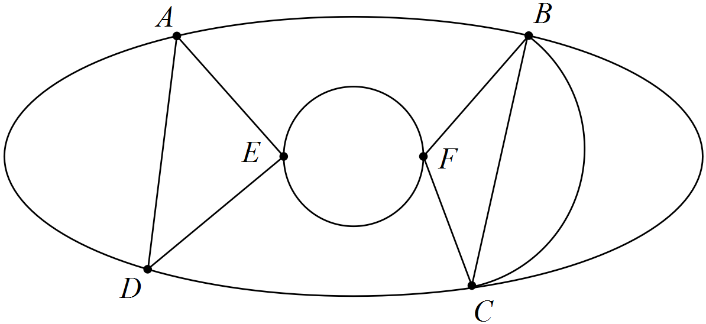

(a) Show that Euler's formula applies to this graph. (2 marks)
Solution
Specific behaviours
states correct values for edges, vertices and faces
substitutes into Euler's formula correctly

(b) Record the degree of each vertex shown in the graph in the table below. (2 marks)

Vertex | A | B | C | D | E | F
Degree | 4 | 5 | 5 | 4 | 4 | 4
Solution
See table
Specific behaviours
at least five correct
all six correct

(c) State a trail that shows the graph is semi-Eulerian. (2 marks)
Solution
Insert Trail here

Specific behaviours
states trail using all edges just once

NB Do not accept explanations based on degree of vertices

(d) A park ranger has to inspect every road in the park. List all possible starting points so that the ranger can complete this task without driving on the same road more than once.
(1 mark)
Solution
B or C
Specific behaviours
states both possible solutions

Question 6 (5 marks)
The scatterplot below shows data from a sample of towns in a region.

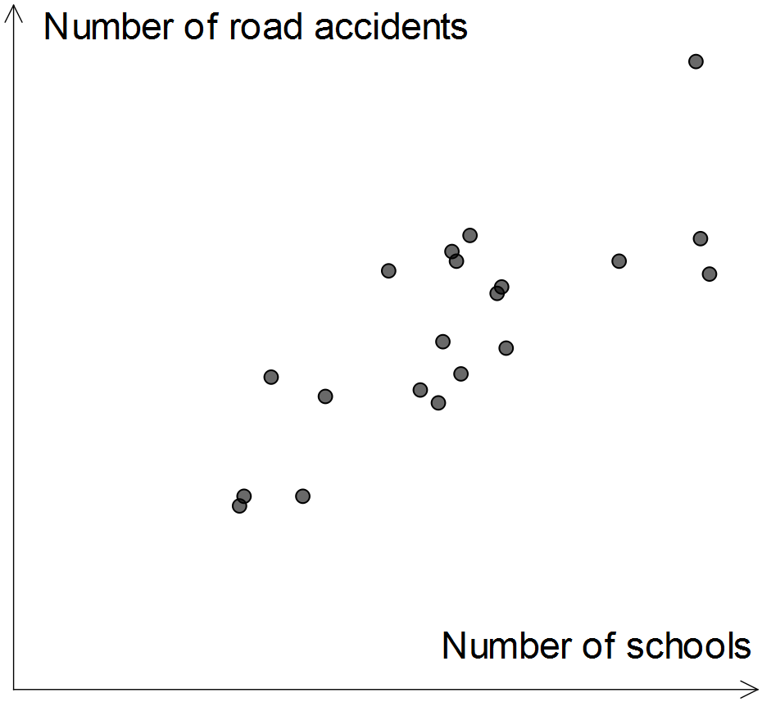

(a) Which of the numbers 1, -1, 0.75, -0.75, 0.5, -0.5, 0.25, -0.25 and 0 is closest to the correlation coefficient between the two variables? Explain your choice. (2 marks)
Solution
0.75
The association is moderate to strong and positive
Specific behaviours
chooses 0.75
supplies reason using strength and direction

(b) A politician saw the graph and claimed the data supported his plan to merge small schools and hence reduce the number of schools in individual towns. Identify a reason the politician might have had to make such a claim. (1 mark)
Solution
The plot shows that towns with fewer schools have fewer road accidents
Specific behaviours
states reason supported by scatterplot

(c) Identify and explain a possible non-causal explanation for the observed association between the number of schools and the number of road accidents in this sample of towns. (2 marks)
Solution
The size of individual towns is likely to be a confounding variable. The two variables are both likely to have a causal association with town size, but not with each other.
Specific behaviours
states town size, or other plausible confounding variable
explains confounding due to common response to third variable

Question 7 (9 marks)
(a) A connected planar graph has one face and three edges.

(i) Determine the number of vertices the graph has. (2 marks)
Solution
Specific behaviours
uses Euler's formula
states correct number

(ii) Sketch a graph with these properties. (2 marks)
Solution
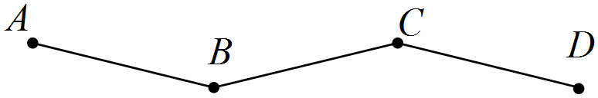
Specific behaviours
sketches a tree
sketch has all other required properties

(b) Consider the graph below.

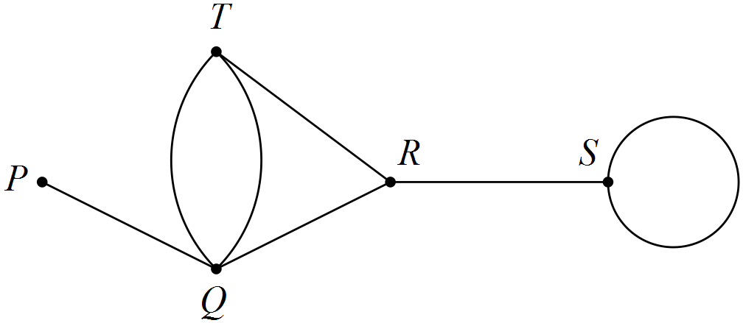

State the length of the longest possible walk in this graph and list, in order from first to last, the vertices visited, so that the walk

(i) is an open trail. (2 marks)
Solution
PQTQRSS - length 6
Specific behaviours
lists vertices with no edges repeated, starting and finishing at different vertices
states correct length

(ii) is a closed path. (3 marks)
Solution
QRTQ (or similar cycle) - length 3
Specific behaviours
lists vertices with no repeats, except for first and last, and no edges repeated
start and finish at same vertex
states correct length

Additional working space

Question number: _________

© 2016 WA Exam Papers. Kennedy Baptist College has a non-exclusive licence to copy and communicate this paper for non-commercial, educational use within the school. No other copying, communication or use is permitted without the express written permission of WA Exam Papers.

